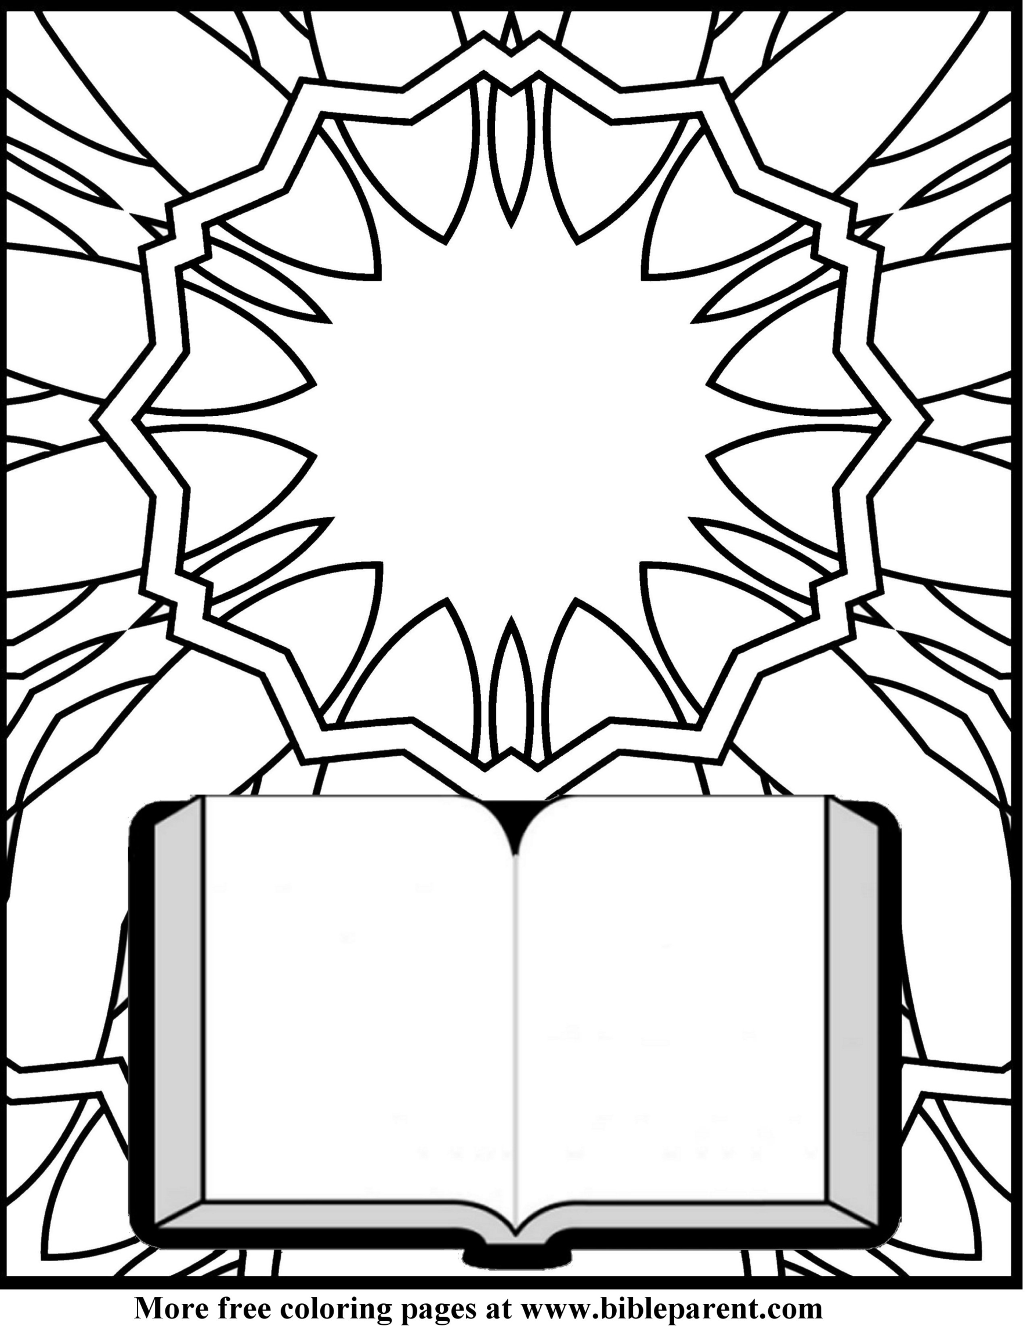

**Hi lite here**

**To Add Text**